Custom AI with Azure Machine Learning services

Hands-on lab step-by-step

May 2018

Information in this document, including URL and other Internet Web site references, is subject to change without notice. Unless otherwise noted, the example companies, organizations, products, domain names, e-mail addresses, logos, people, places, and events depicted herein are fictitious, and no association with any real company, organization, product, domain name, e-mail address, logo, person, place or event is intended or should be inferred. Complying with all applicable copyright laws is the responsibility of the user. Without limiting the rights under copyright, no part of this document may be reproduced, stored in or introduced into a retrieval system, or transmitted in any form or by any means (electronic, mechanical, photocopying, recording, or otherwise), or for any purpose, without the express written permission of Microsoft Corporation.

Microsoft may have patents, patent applications, trademarks, copyrights, or other intellectual property rights covering subject matter in this document. Except as expressly provided in any written license agreement from Microsoft, the furnishing of this document does not give you any license to these patents, trademarks, copyrights, or other intellectual property.

The names of manufacturers, products, or URLs are provided for informational purposes only, and Microsoft makes no representations and warranties, either expressed, implied, or statutory, regarding these manufacturers or the use of the products with any Microsoft technologies. The inclusion of a manufacturer or product does not imply endorsement of Microsoft of the manufacturer or product. Links may be provided to third-party sites. Such sites are not under the control of Microsoft and Microsoft is not responsible for the contents of any linked site or any link contained in a linked site, or any changes or updates to such sites. Microsoft is not responsible for webcasting or any other form of transmission received from any linked site. Microsoft is providing these links to you only as a convenience, and the inclusion of any link does not imply endorsement of Microsoft of the site or the products contained therein.

© 2018 Microsoft Corporation. All rights reserved.

Microsoft and the trademarks listed at <https://www.microsoft.com/en-us/legal/intellectualproperty/Trademarks/Usage/General.aspx> are trademarks of the Microsoft group of companies. All other trademarks are the property of their respective owners.

Contents

Custom AI with Azure Machine Learning services 1

Abstract and learning objectives 1

Overview 1

Requirements 1

Exercise 1: Setting up your Data Science Environment 2

Task 1: Provision the Windows Data Science Virtual Machine 2

Task 2: Verify remote desktop access to Data Science VM 7

Task 3: Initialize Azure Machine Learning Workbench 9

Exercise 2: Setup Azure Machine Learning accounts 11

Task 1: Provision Azure Machine Learning Experimentation service 11

Task 2: Create the Azure Machine Learning project 13

Task 3: Stop the Data Science VM 17

## Custom AI with Azure Machine Learning services

## Abstract and learning objectives

In this workshop, you will learn to create intelligent solutions atop unstructured text data by designing and implementing a text analytics pipeline. You will also learn how to build a binary classifier using a simple neural network that can be used to classify the textual data. Also, you will learn how to deploy multiple kinds of predictive services using Azure Machine Learning.

Along the way, you will get to consider the following technologies and services:

* Azure Machine Learning services
* TensorFlow

## Overview

In this workshop, you will help Contoso Ltd. Build a proof of concept that shows how they could build a solution that amplifies the claims processing capabilities of their agents.

## Requirements

1. Microsoft Azure subscription must be pay-as-you-go or MSDN
   1. Trial subscriptions will not work

## Exercise 1: Setting up your Data Science Environment

Duration: 30 minutes

#### Task 1: Provision the Windows Data Science Virtual Machine

1. Navigate to the Azure Portal at <https://portal.azure.com>.
2. Select **Create a resource**.  
   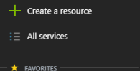
3. Select **AI + Cognitive Services** and then select **Data Science Virtual Machine Windows 2016**.  
   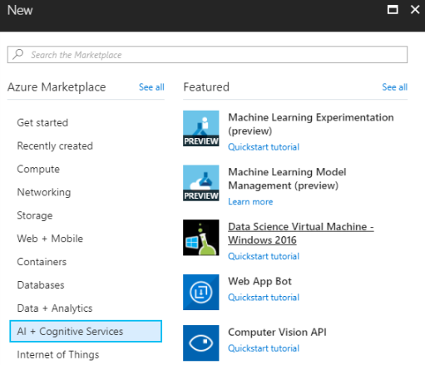
4. On the **Basics** blade provide the following inputs:
   1. **Name**: enter labvm
   2. **VM disk type**: select HDD. This will enable you to use a GPU based machine if you choose to in the subsequent step.
   3. **User name**: enter demouser
   4. **Password and Confirm Password:** enter Abc!1234567890
   5. **Subscription**: select your Azure subscription
   6. **Resource group**: select Create new and provide the name mcw-ai-lab
   7. **Location**: select either South Central US or East US (or any of the regions in which the NC-series VM’s are currently available, see the [regions service page](https://azure.microsoft.com/en-us/global-infrastructure/services/) for an up to date listing).

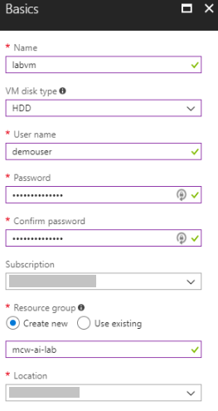

1. Select **OK**.
2. On the **Choose a size** blade, select **NC6 Standard** and choose **Select**.

**Getting an Error?**

If your subscription does not have access to NC series VM’s or you hit a quota error, you *can* use a smaller VM for this lab, we suggest one that has at least 14GB of RAM such as a D4s_v3 or a DS3_v2.

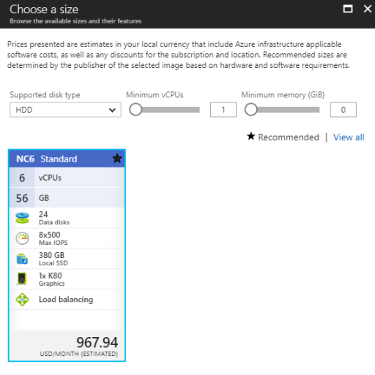

1. Leave all values on the **Settings** blade at their defaults and select **OK**.  
   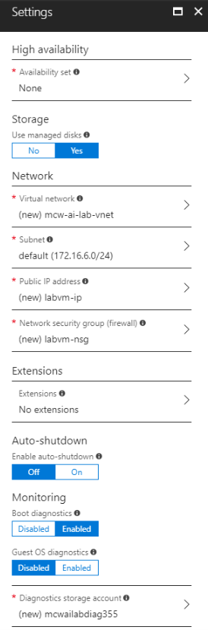
2. On the **Create** blade, review the summary and then select **Create.**  
   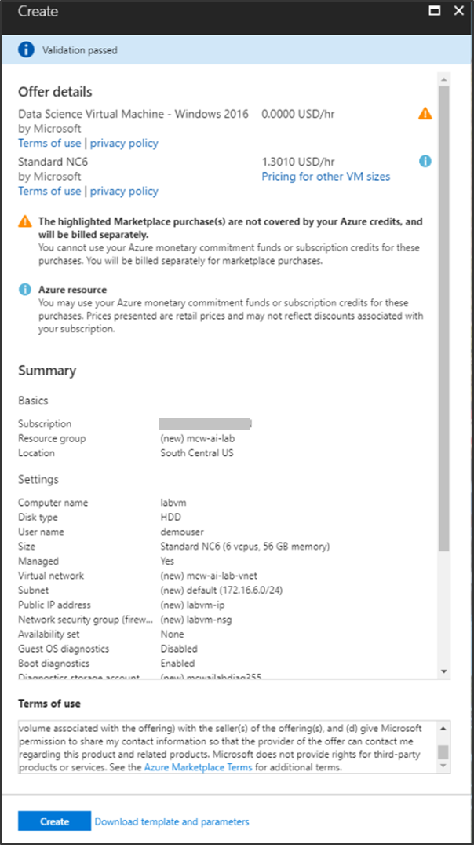
3. The VM should take 10-15 minutes to provision.

#### Task 2: Verify remote desktop access to Data Science VM

1. When the VM is ready, you should see a notification. Select **Go to resources** to view the deployed Data Science VM in the Portal.  
   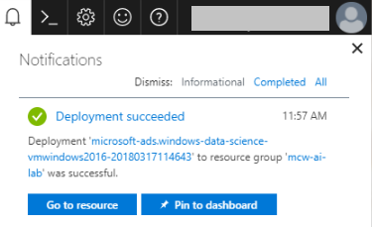
2. On the blade for the VM, select **Connect** and then select **Download RDP File**. This will download a Remote Desktop (RDP) file.

Screenshot of the Connect button.

1. Open the downloaded RDP file.
2. At the prompt, ensure **Clipboard** is checked and select **Continue**.  
   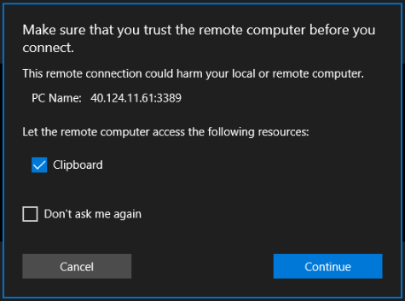
3. Enter the **username** (demouser) and **password** (Abc!1234567890) and select **Connect** to login.  
   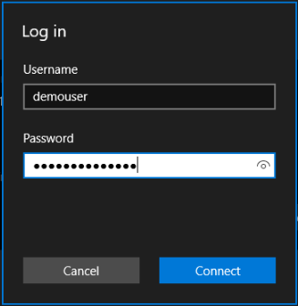
4. Select **Connect** on the dialog that follows.  
   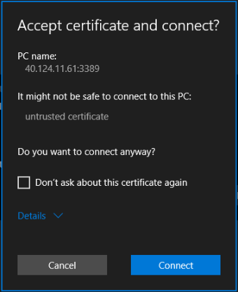
5. Within a few moments, you should see the desktop for your new Data Science Virtual Machine.  
   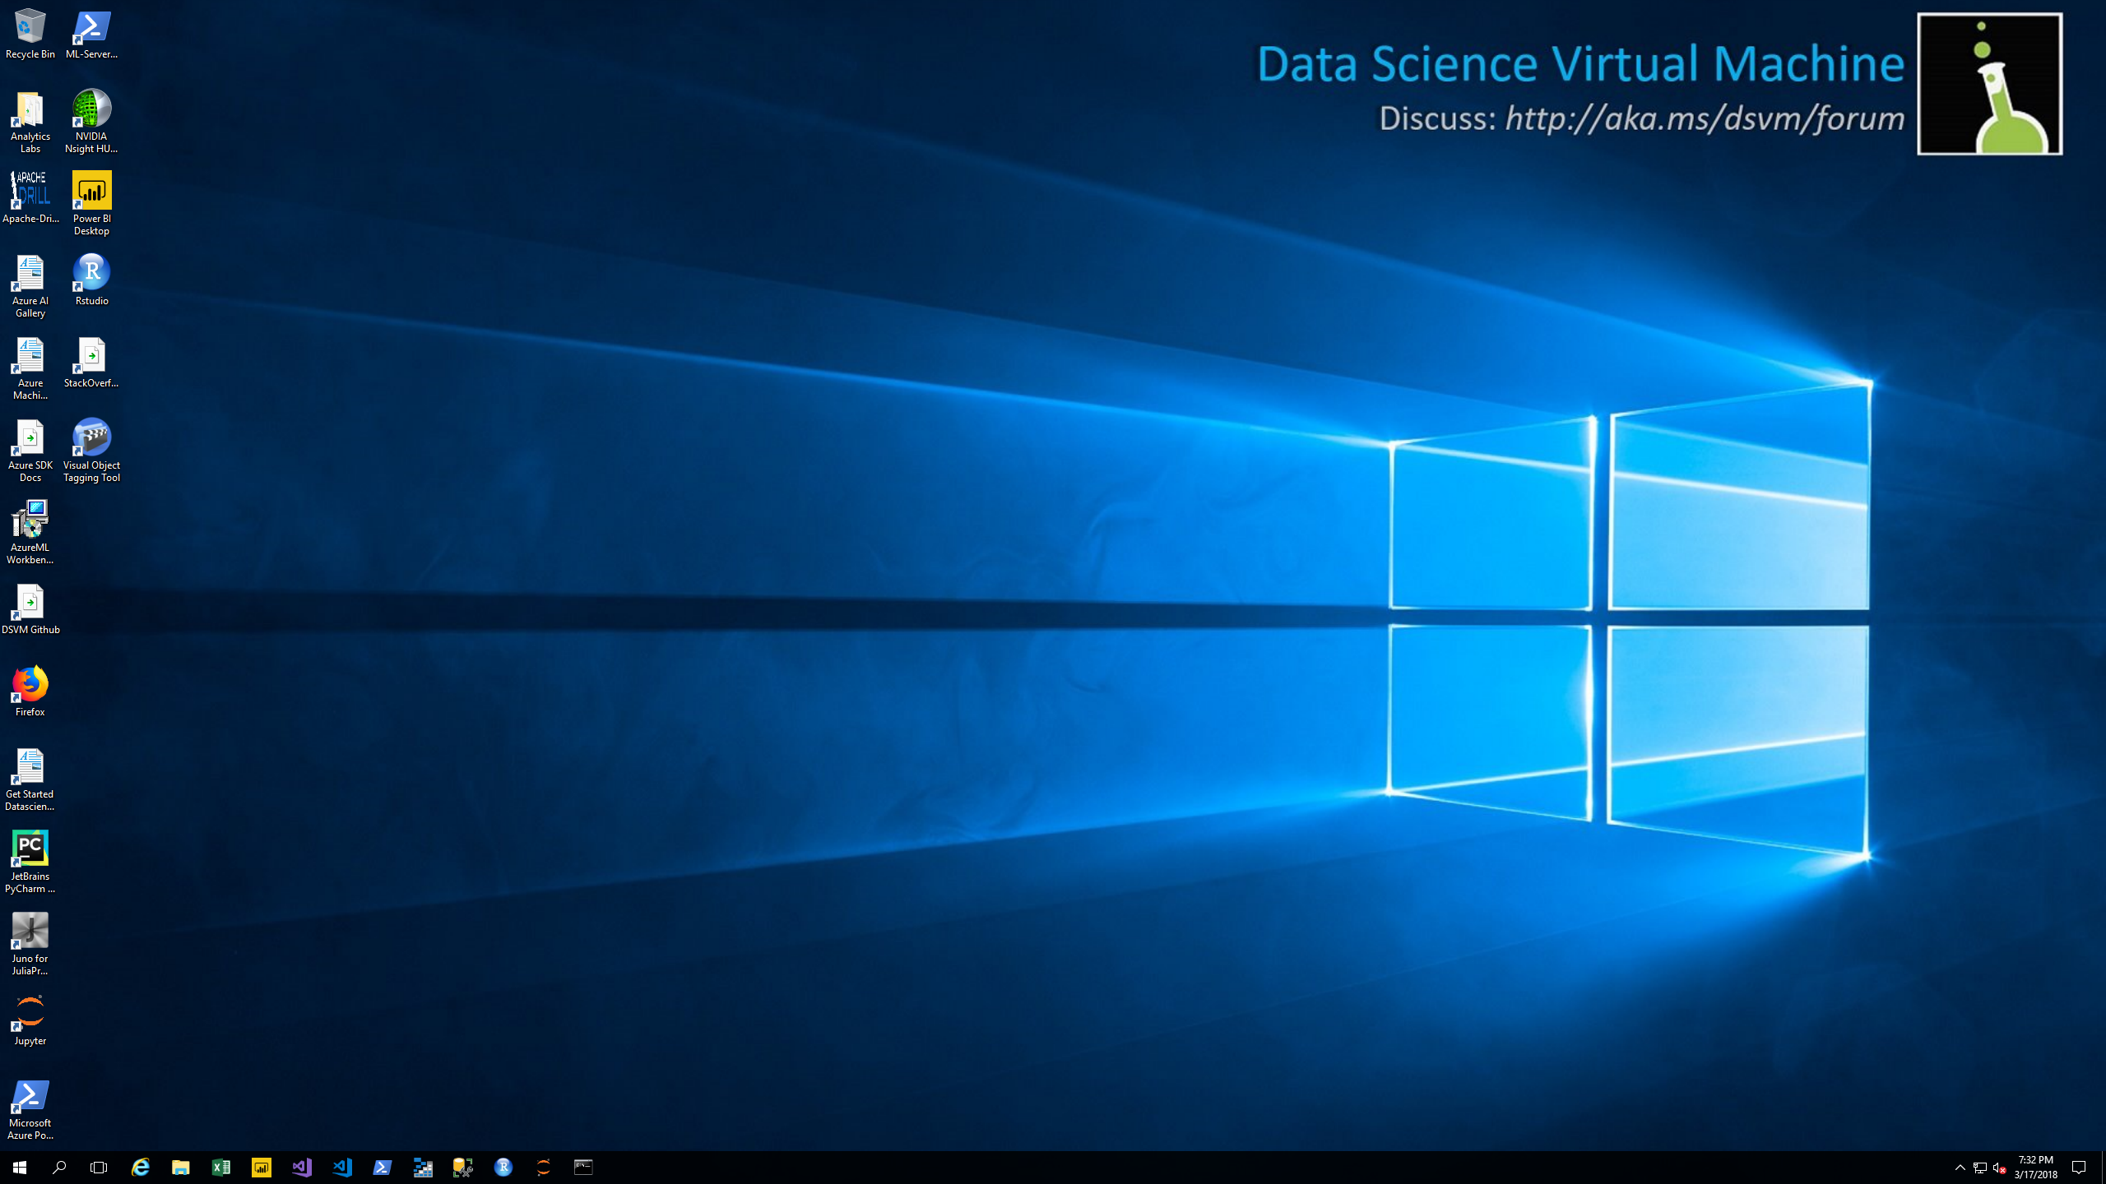

#### Task 3: Initialize Azure Machine Learning Workbench

Before using the Azure Machine Learning Workbench on the Data Science VM, you will need to take the one-time action of double-clicking on the AzureML Workbench Setup icon on the desktop to install your instance of the workbench.

1. Within the RDP session to the Data Science VM.
2. Using Firefox (already installed on the machine), download the Azure Machine Learning Workbench from:

<https://aka.ms/azureml-wb-msi>

|  |
| --- |
| **NOTE**: **Do not** use the AzureML Workbench Setup link that is present on the desktop. This will download an old version of the Workbench. Screenshot of the AzureML Workbench Setup desktop icon. |

1. Double-click the downloaded file to install the Workbench.
2. At the **Open File – Security Warning** dialog, select **Run**.  
   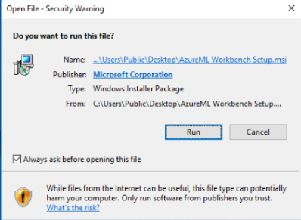
3. Step through all the prompts leaving all values at their defaults to complete the Workbench installation. The installation will take about 25 minutes. Use the **X** to close the install when it is finished.

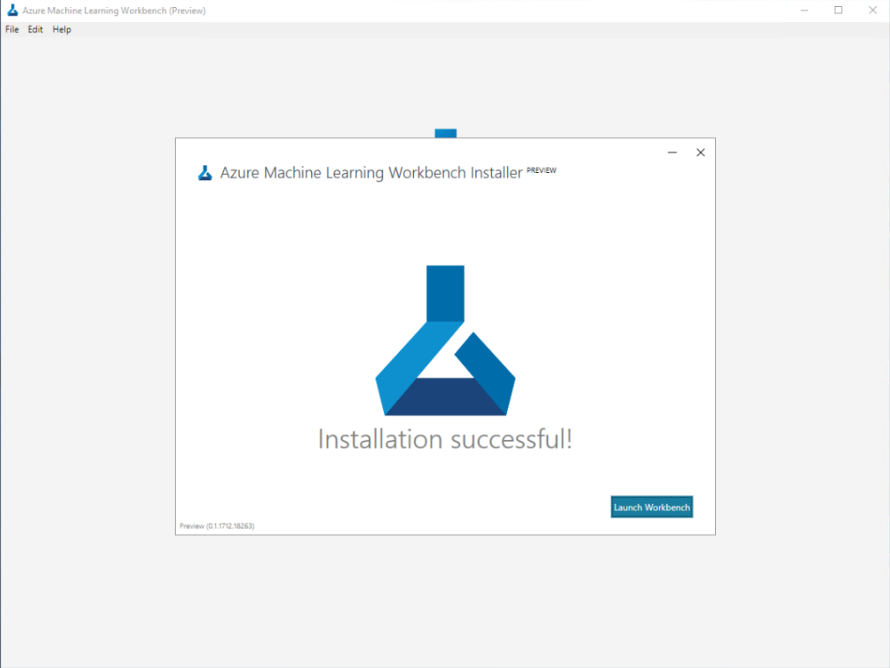

## Exercise 2: Setup Azure Machine Learning accounts

Duration: 30 minutes

In this exercise, you will setup your Azure Machine Learning Experimentation and Model Management Accounts and get your project environment setup.

#### Task 1: Provision Azure Machine Learning Experimentation service

1. Navigate to the Azure Portal.
2. Select **Create a resource**.  
   
3. Select **AI + Cognitive Services** and then select **Machine Learning Experimentation**   
   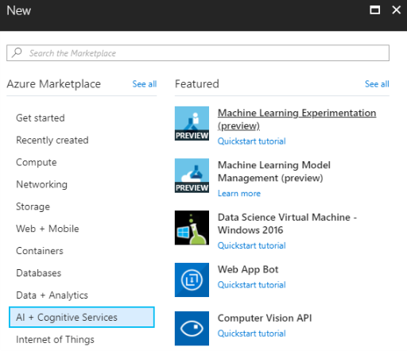
4. On the **ML Experimentation** blade, provide the following:
   1. **Experimentation account name**: provide a name for your experimentation account.
   2. **Subscription:** select your Azure subscription.
   3. **Resource group**: select the mcw-ai-lab resource group you previously created.
   4. **Location**: select the region nearest to where you deployed your Data Science VM. It’s OK if they are not in exactly the same region, but try to select a region that is close to minimize latency.
   5. **Number of seats**: leave at 2.
   6. **Storage account**: select create new and provide a unique name for the new storage account.
   7. **Workspace for Experimentation account**: provide a unique name for the workspace.
   8. **Assign owner for the workspace**: leave the owner assigned to you.
   9. **Create Model Management account**: leave checked.
   10. **Account name**: provide a name for your model management account.
   11. **Model Management pricing tier**: select the S1 pricing tier.  
       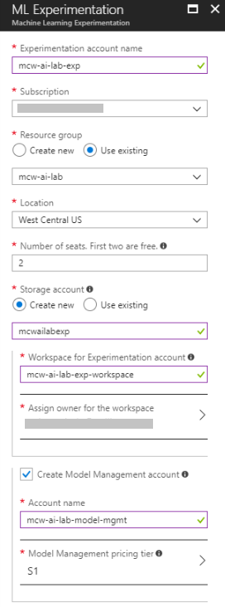
5. Select **Create** to provision the Experimentation and Model Management Service. The deployment should take about 2 minutes.
6. When the deployment completes, navigate to your mcw-ai-lab resource group and confirm that you see an instance of Machine Learning Experimentation and Machine Learning Model Management.  
   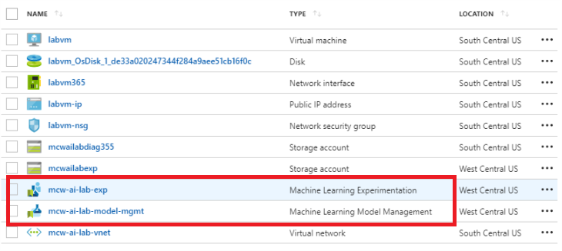

#### Task 2: Create the Azure Machine Learning project

1. Connect to the labvm via RDP. If you stopped the VM, remember to Start it up again before attempting to connect.
2. From the **Start** menu, launch **Azure Machine Learning Workbench**.
3. Select **Sign in with Microsoft.**  
   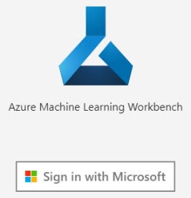
4. Sign in with the credentials you used when creating the Experimentation Service in the Azure Portal.  
   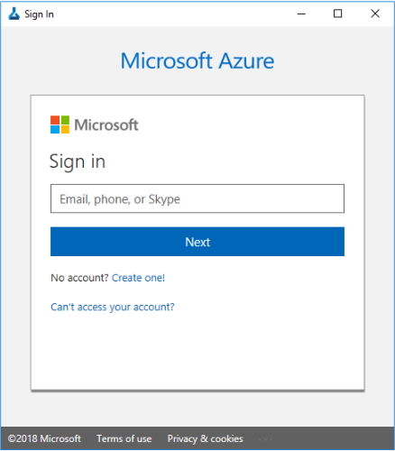
5. After successfully signing in, the Workbench interface should appear, listing the experimentation workspace that you created.  
   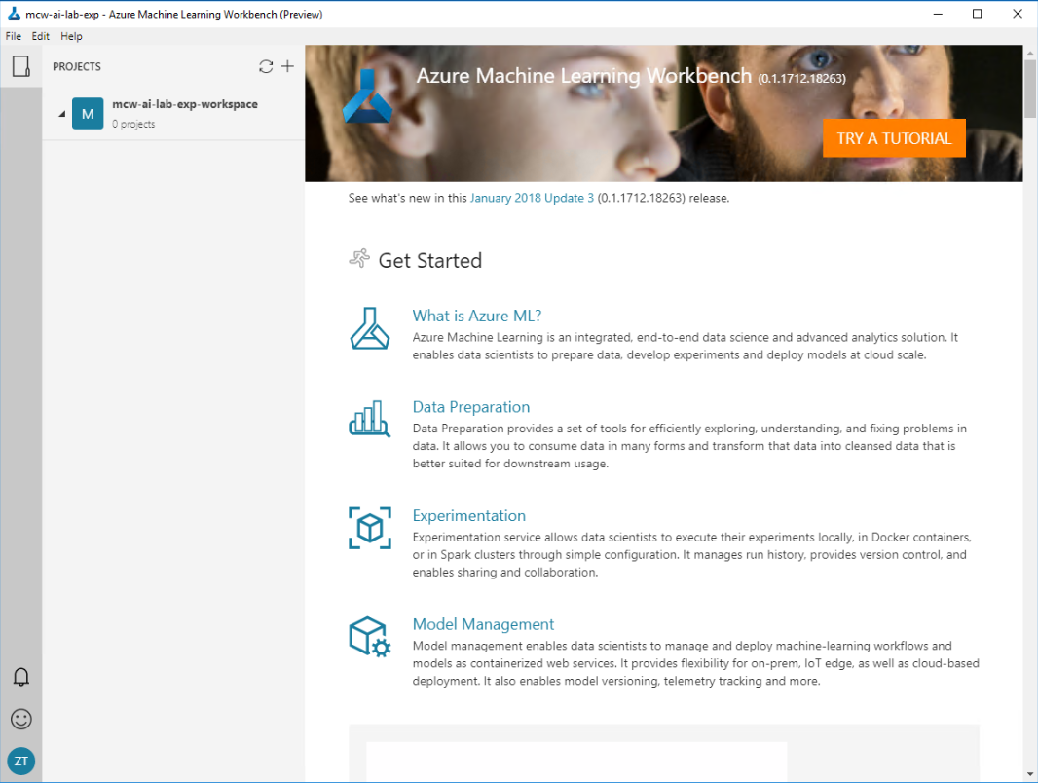
6. From the **File** Menu, select **New Project…**  
   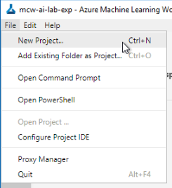
7. In the **New Project** blade that appears, provide the following:
   1. **Project name**: mcw-ai-lab
   2. **Project directory**: C:\HOL
   3. **Project description**: leave blank
   4. **Vistualstudio.com GIT Repository URL**: leave blank
   5. **Selected workspace**: select the ML Experimentation Workspace you created.  
      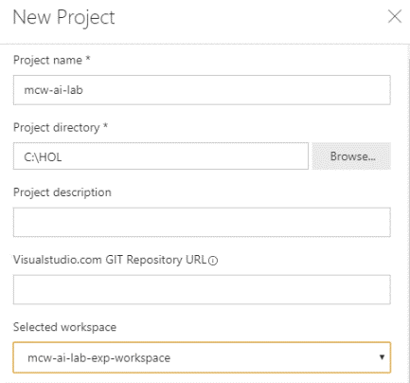
8. In the Search Project Templates, enter **TDSP** and select the item called **TDSP Template**.  
   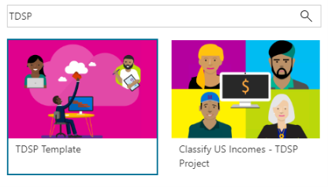
9. Select **Create.**
10. The template will download, and a few moments you should see the TDSP project dashboard.   
    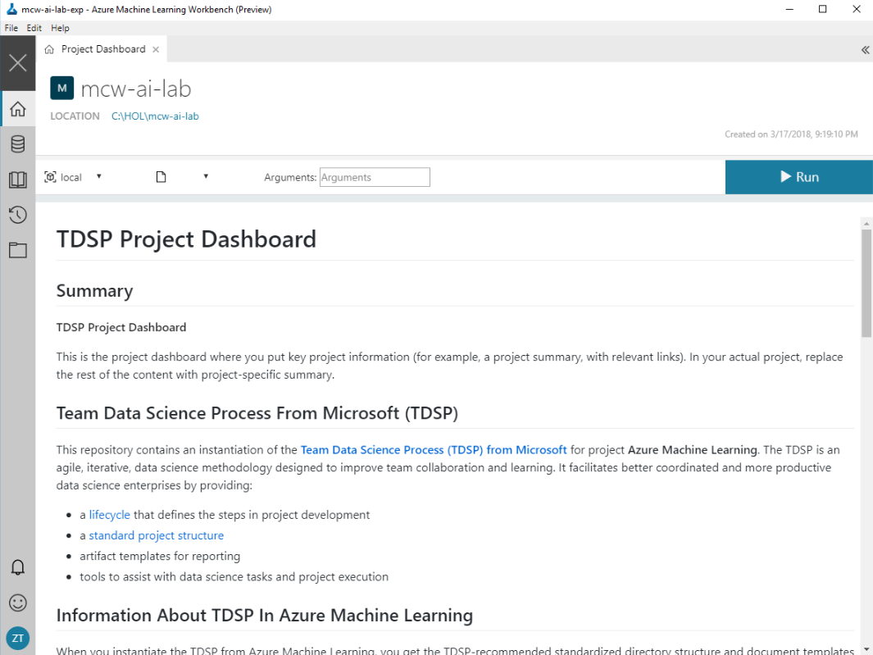

#### Task 3: Stop the Data Science VM

Since you are performing this setup the day before the hands-on lab, you can optionally Stop the VM to save on costs overnight and resume it when you are ready to start on the lab. Follow these steps to Stop the VM:

1. Save your project in the Workbench and close the Workbench.
2. Return to the Azure Portal.
3. Navigate to the blade of your labvm.
4. Select the **Stop** button.  
   Screenshot of the Stop button.

**NOTE:** When you are ready to resume the VM, simply follow the previous steps and instead of selecting **Stop**, select **Start**. Your VM will take about 5 minutes to start up, after which you can use the **Connect** button in the VM blade to RDP into the VM as before.

Stop